**Change Request -Tour Package**

1. Package Booking- change in email templet

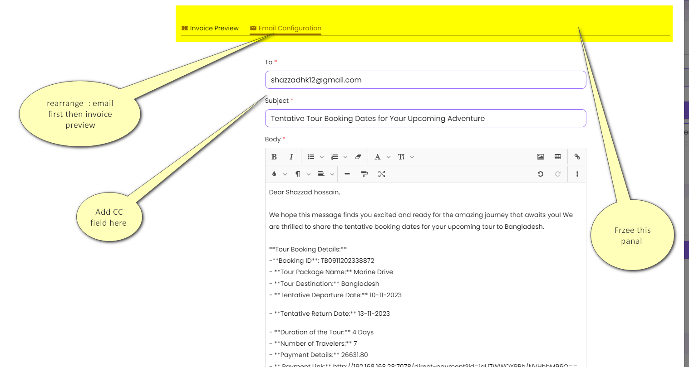

* 1. Change this template for
     1. Booking list email action
     2. Payment request email request

1. Freeze the header of every UI

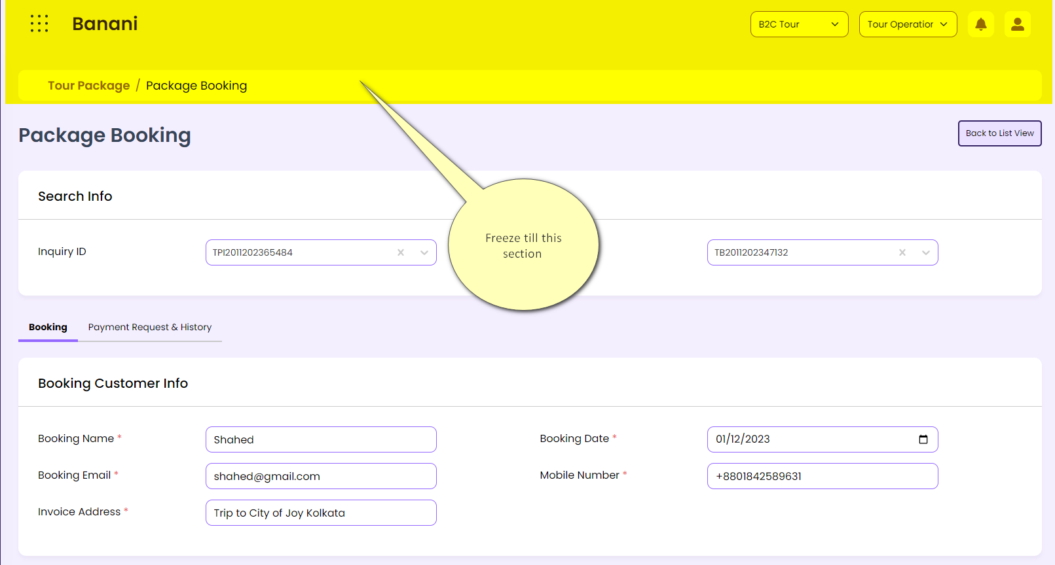

1. General Policy - The user will be able to select any one from the options in amount or percentage. The user will be able to select the radio button to save the below. Based on the setup the system will show the respective value.
   1. In amount
   2. in percentage

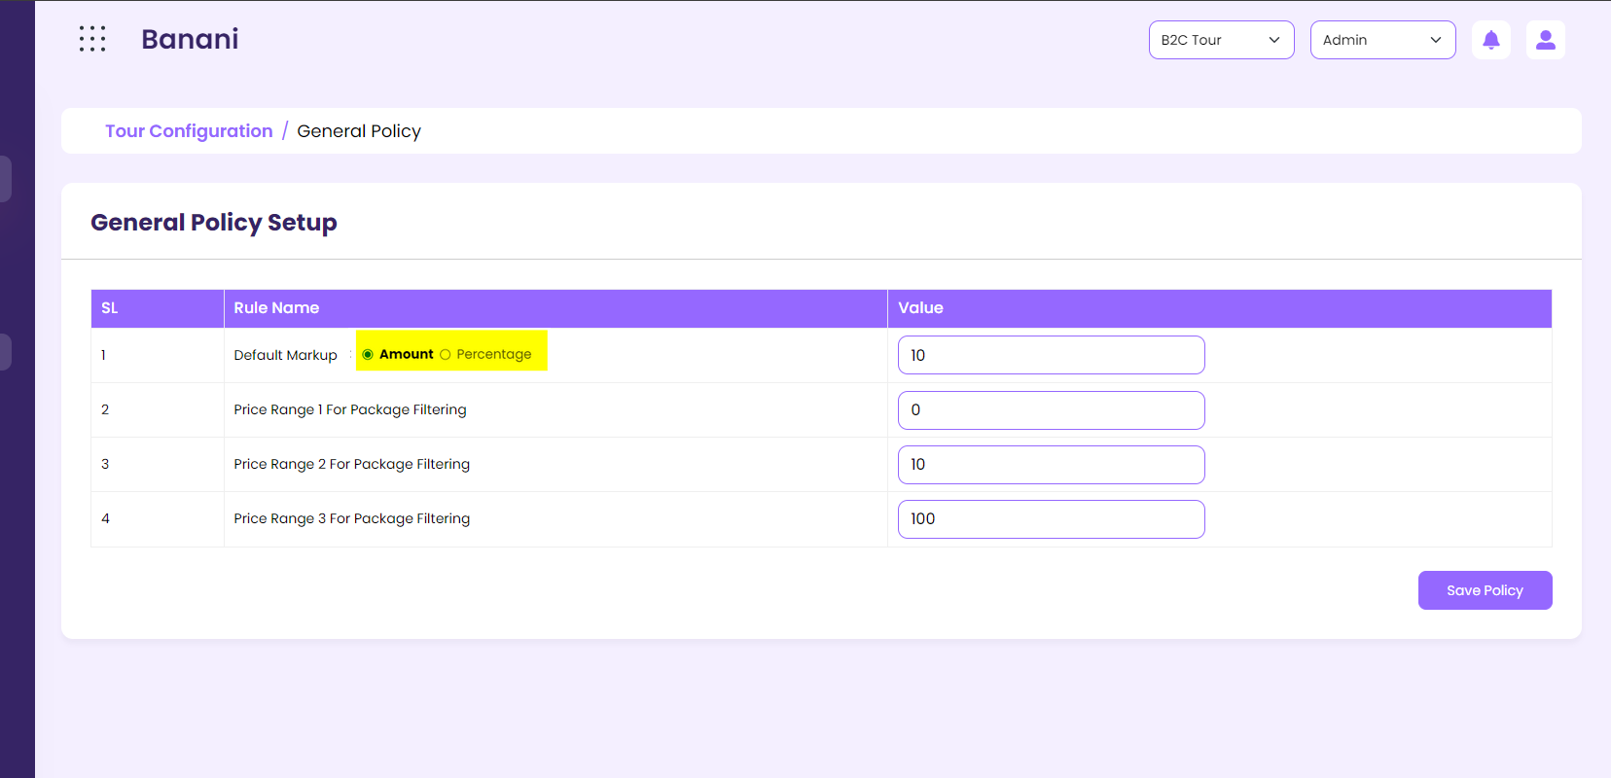

1. For the selection of percentages the system will show “%” beside the respective fields
2. For the selection of the amount the system will show “BDT” beside the respective fields
3. Current markup & default markup in booking Package Booking – The user will be able to select any one from the options in amount or percentage. The user will be able to select the radio button to save the below

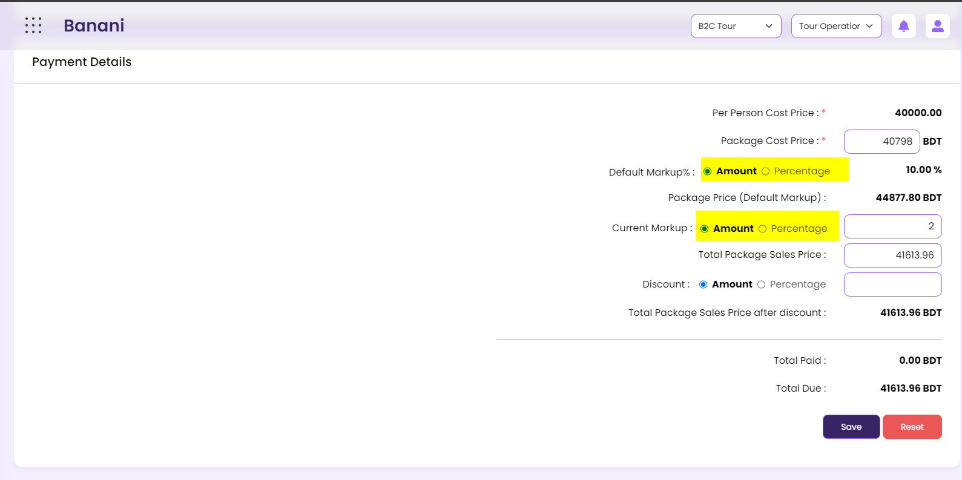

* 1. In amount
  2. in percentage
  3. For the default markup, the setup option will be selected and will show in read-only mode
  4. For current markup, the system will show the percentage as selected by default. User will be able to change this
  5. For the selection of percentages the system will show “%” beside the respective field like current markup, default markup, discount
  6. For the selection of the amount the system will show “BDT” beside the respective field like current markup, default markup, discount

1. Change in Package Inquiry Response UI

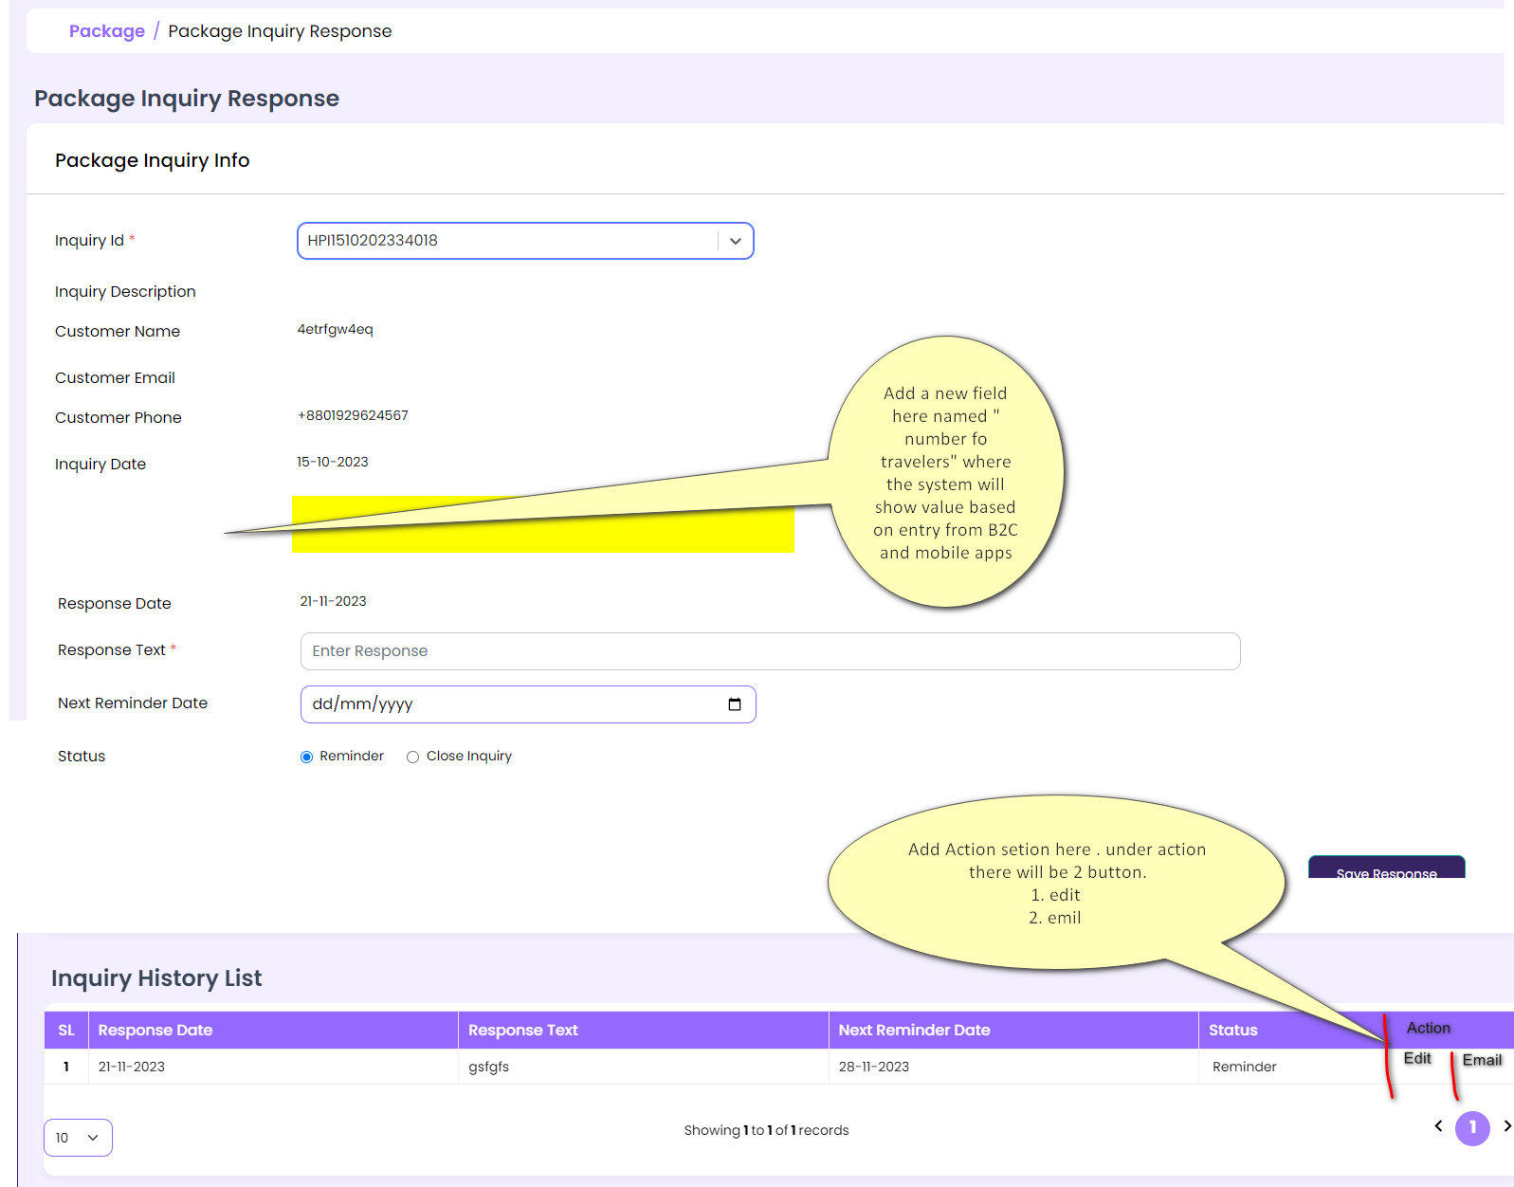

* 1. Add a new field named “ Number of Travelers field” here. the value will come here in read-only mode.
  2. Allow the user to select the time with the date for the next remainder date.
  3. Add an action section with the below action icon button
     1. Edit
        1. On clicking here the system will load the last saved data in the upper part for further change
        2. the edit button will be available only for the last saved one
     2. Email
        1. On clicking the send mail button the system will pop up the send mail UI and allow the user to enter/ edit the mail template and send mail to the respective customer.

1. Change in package inquiry creation UI

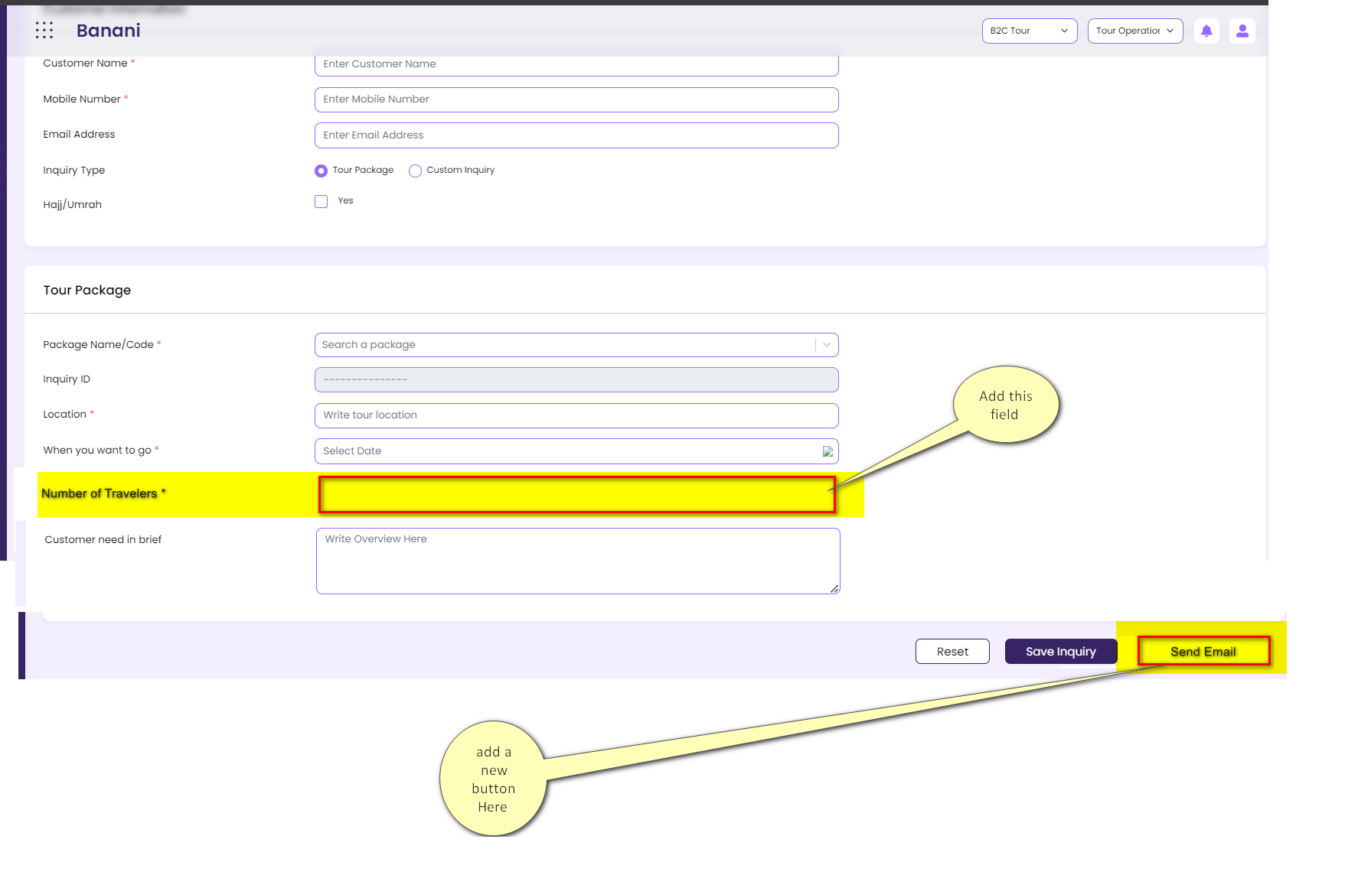

* 1. Add a new field named “ Number of Travelers field” here.
     1. The field design will be the same as the package creation and package booking UI.
     2. The user will be able to select adult, child, infant, and age for the selected respective child
     3. This field will come both for custom packages and tour package
  2. Add an action button
     1. Email
        1. On clicking the send mail button the system will pop up the send mail UI and allow the user to enter/ edit the mail template and send mail to the respective customer.

1. Package booking – change in payment request

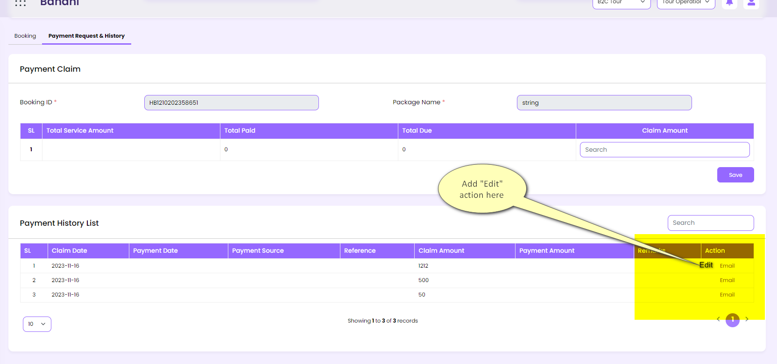

* 1. Add an action section with the below action icon button
     1. Edit
        1. On clicking here the system will load the last saved data in the upper part for further change
        2. the edit button will be available only for the last saved one
  2. instead of the edit button and email add an icon here for booth edit and email.

1. Location -change in field name from “ video link” to “ vlog link

